**Service Provider**

**Name**

مهاب محمد فوزي محمد

Muhab Mohamed Fawzy Mohamed

**Description**

A simple website that includes basic characteristics of service provider’s concept, includes:

* Login
* Registration
* Ban system
* User profile
* User management (edit profile, set admin)
* Service management (add new service
* User service management (assign service to user, delete server from user)
* Service request submission & review

1. Homepage

Main page of the website, contains hyperlinks and sincere welcoming.

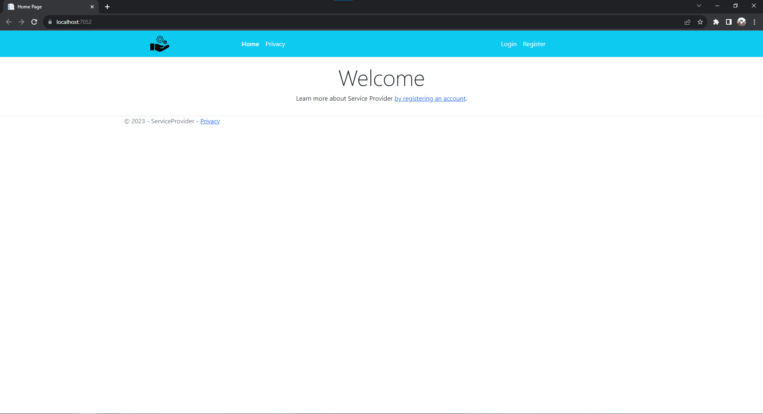

1. Privacy Policy

Contains website’s policies and terms of usage.

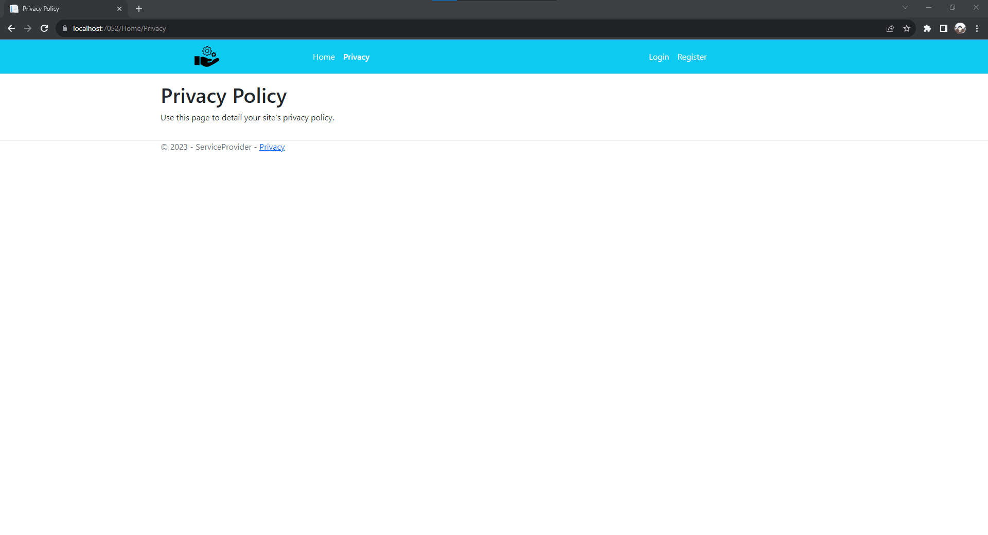

1. Login

Where a user can log into his account by email address and password.

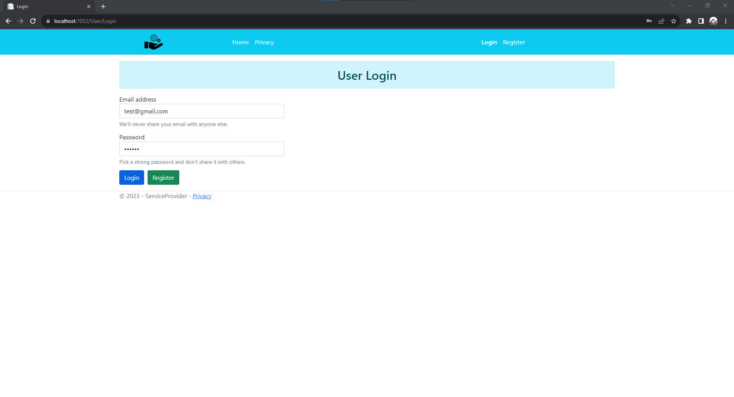

1. Registration

Where user can register a new account by few information.

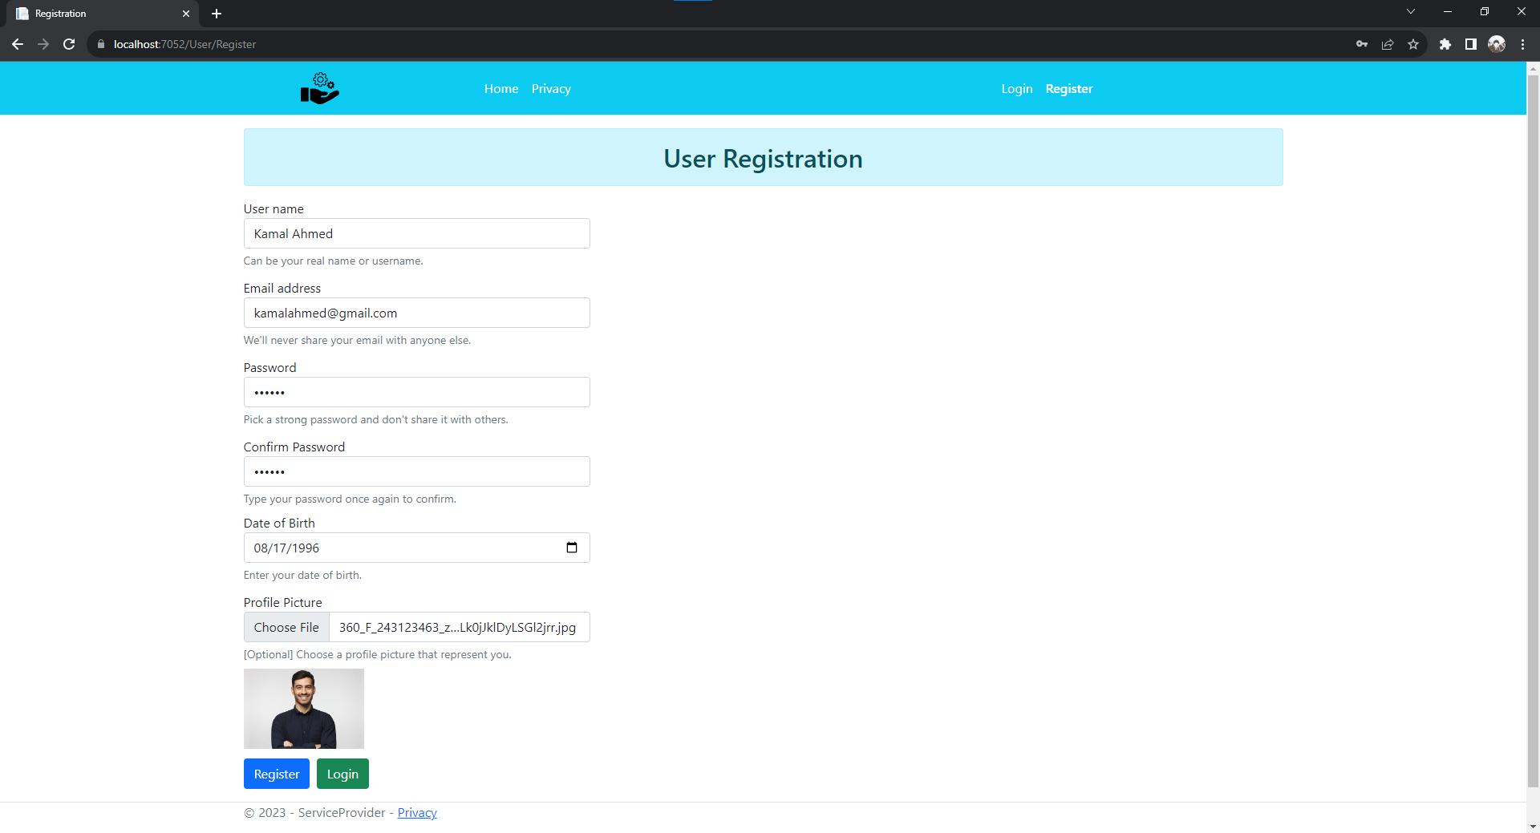

1. Homepage - User

Home page of a normal user after login, contains navigations to user profile, log out and new service request.

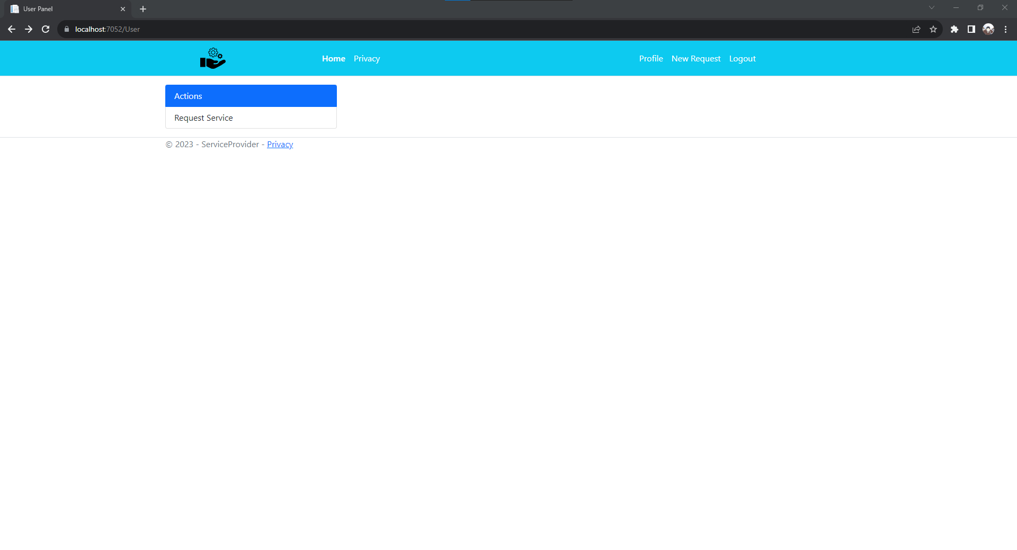

1. User Profile

Where user can view/update his profile’s personal information.

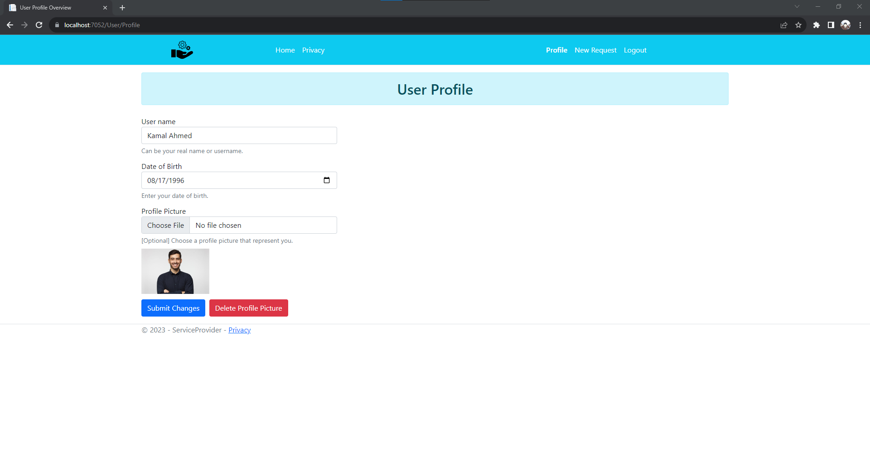

1. Service Request Submission

Enables user to request a service of available services provided by website, a service request can be later reviewed by an administrator.

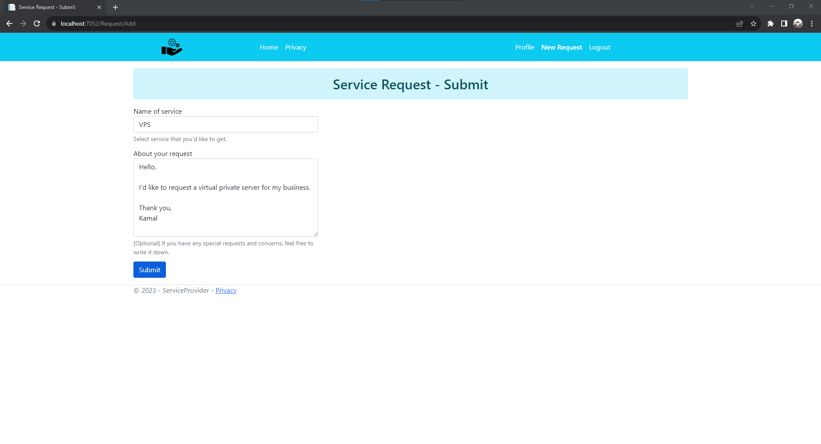

1. Homepage - Admin

Home page of an administrator user after login, contains navigations to user profile, log out and new service request, and special access to users, services, requests and bans management.

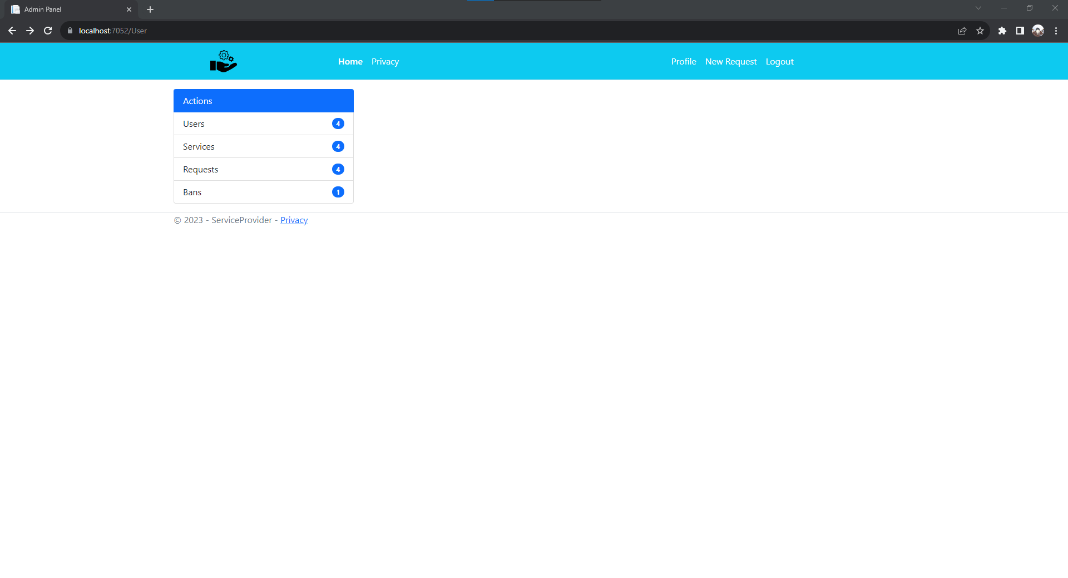

1. User Management

Where an administrator can view all concurrent users and apply some actions to them.

Actions:

* View/Modify Profile
* Manage Assigned Services
* Set/Unset Administrator
* Ban/Unban User

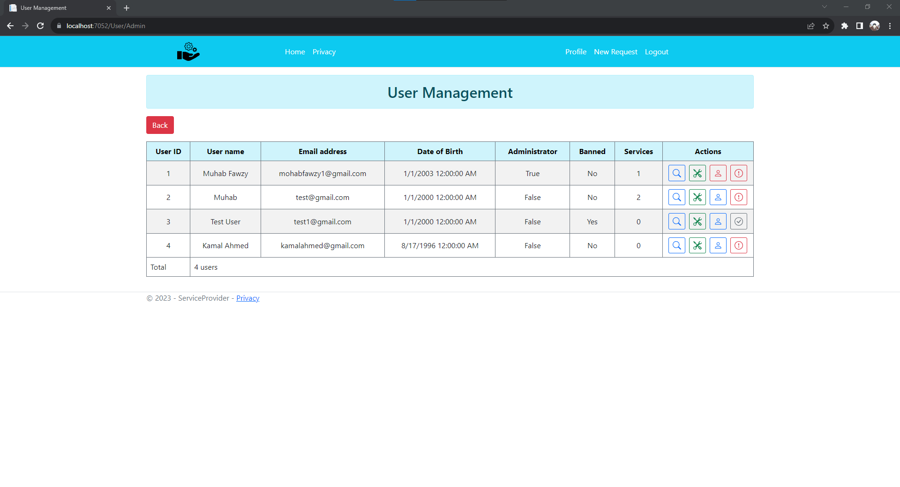

1. User Service Management

Where an administrator can view/add/delete assigned services for a certain user.

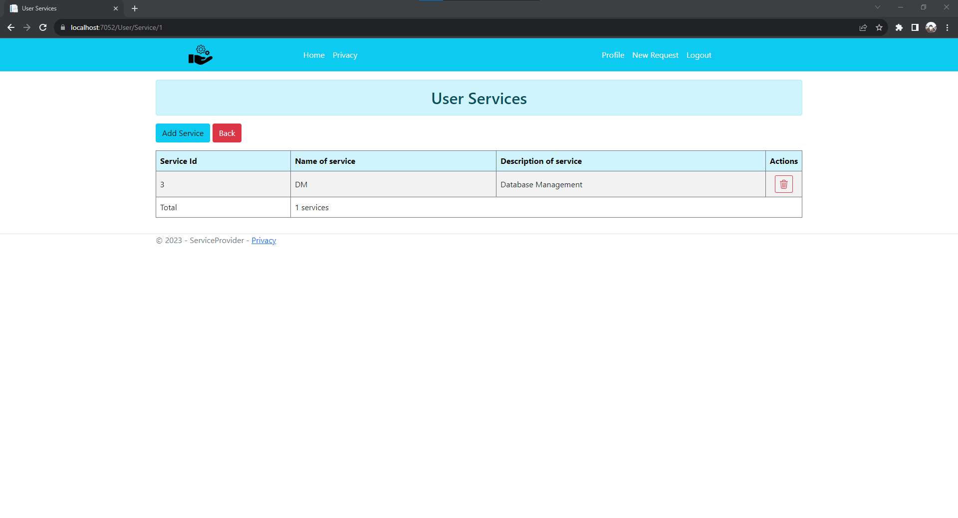

1. Add User Service

Where an administrator can assign a service to a certain user.

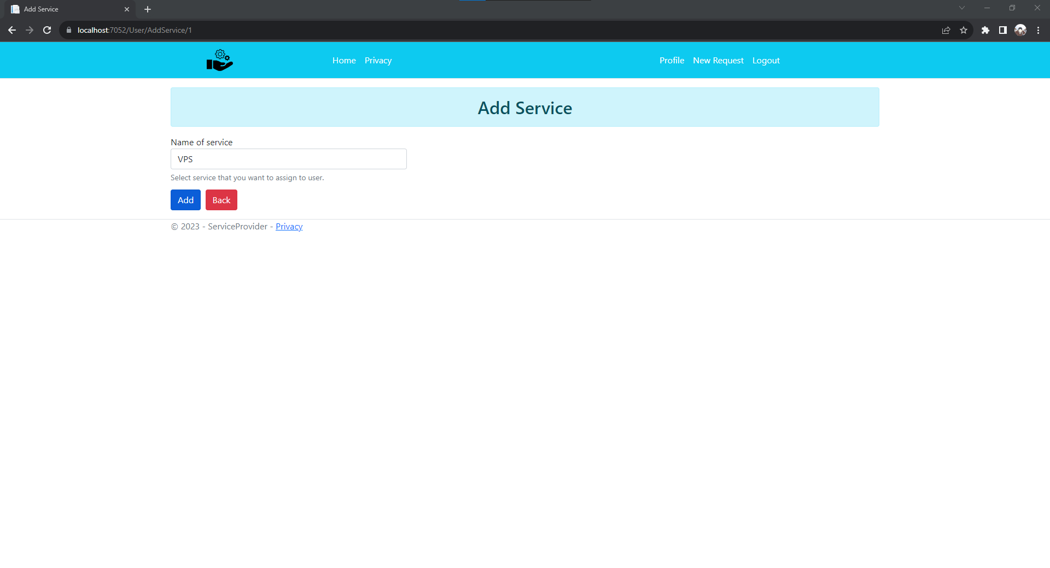

1. Delete User Service

Where an administrator can delete an assigned service from a certain user.

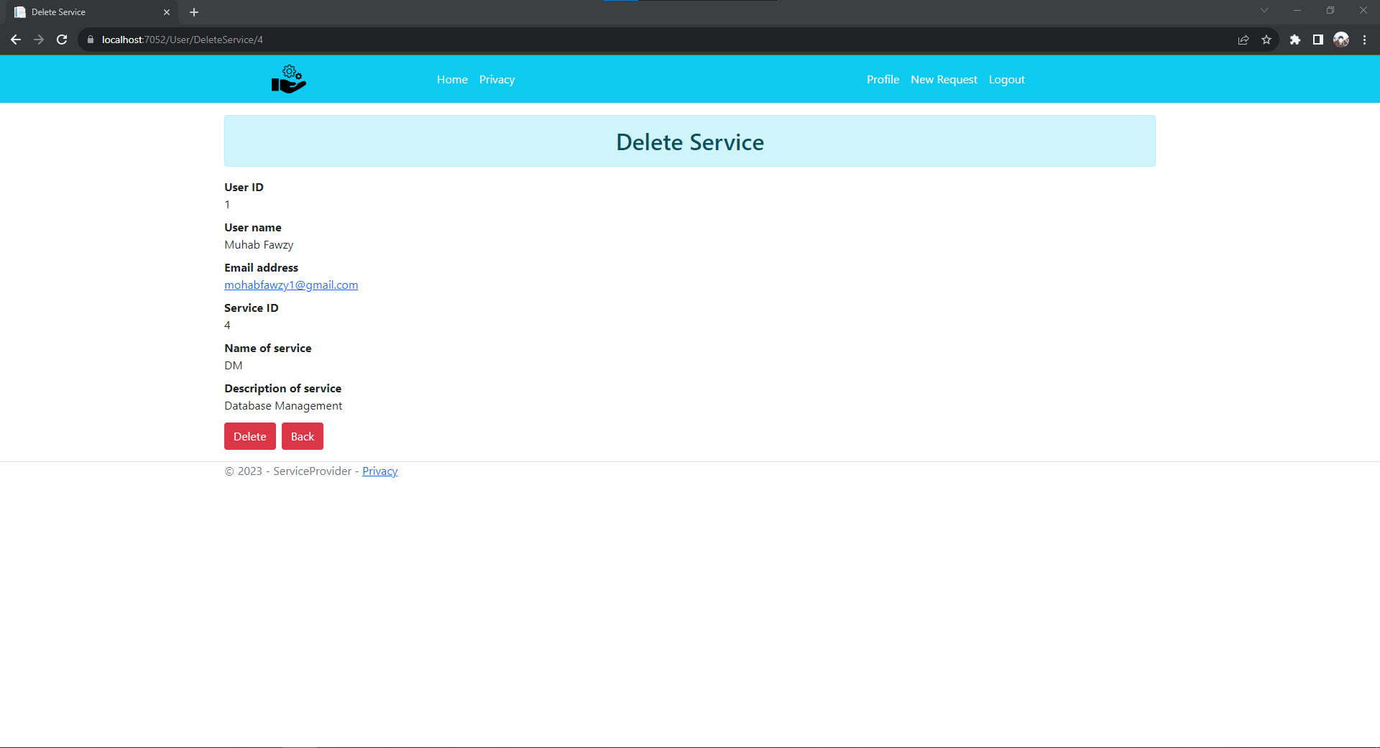

1. Service Request Management

Where an administrator can review service requests ordered by newest to oldest.

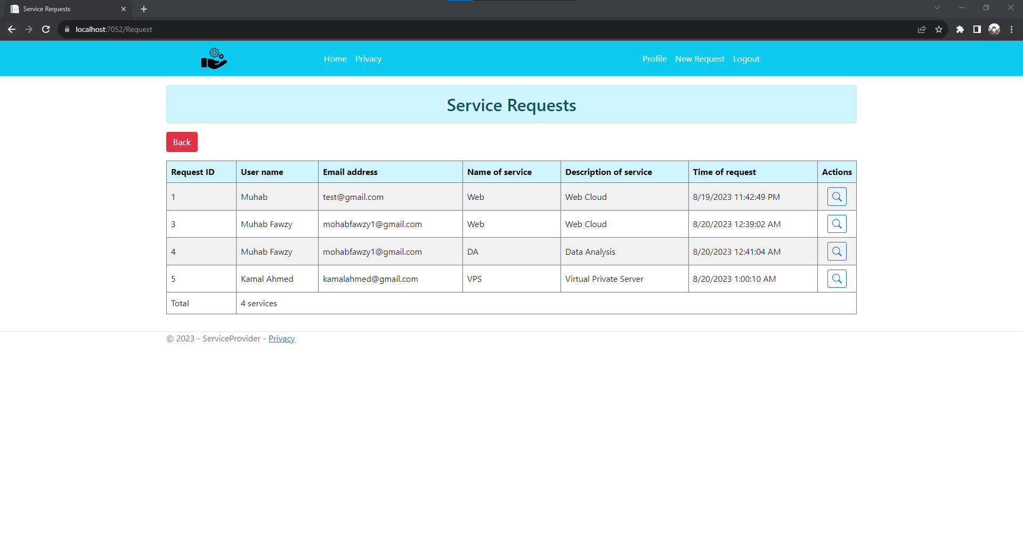

1. Service Request Details

Where an administrator can view details of a certain service request.

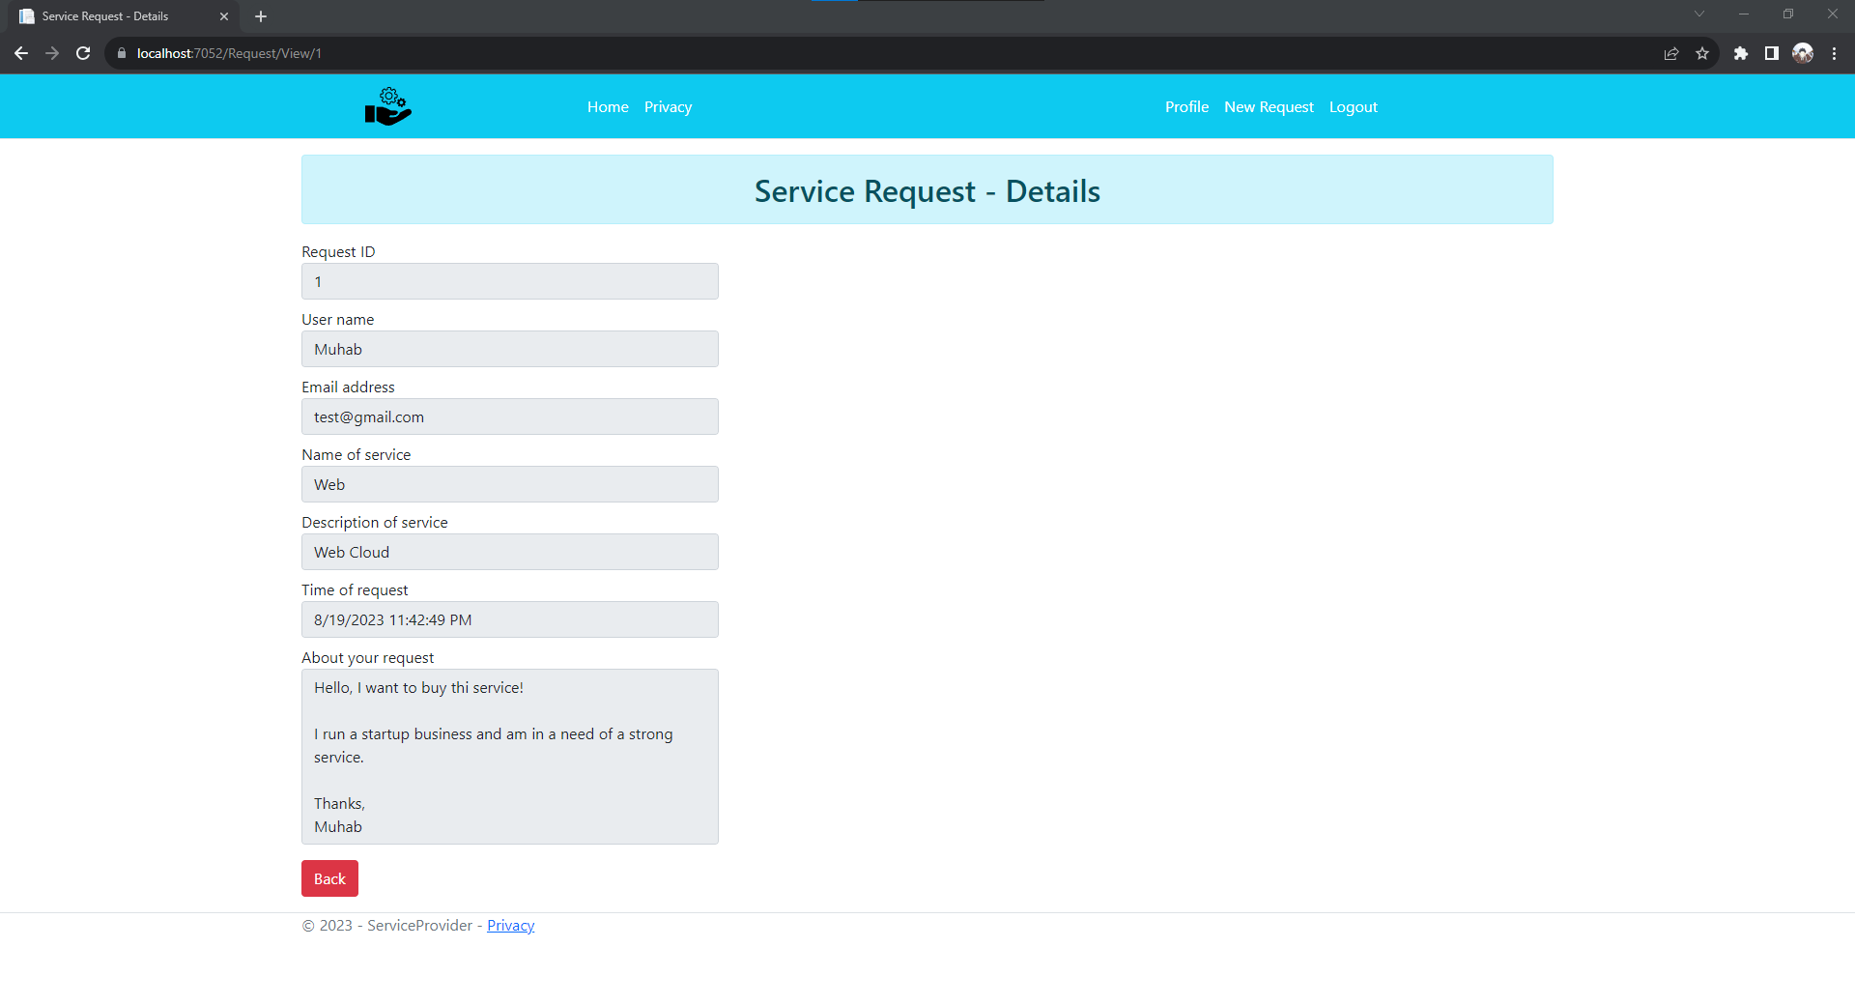

1. Ban Management

Where an administrator can view concurrent banned users and apply some actions.

Actions:

* Ban User
* Unban User

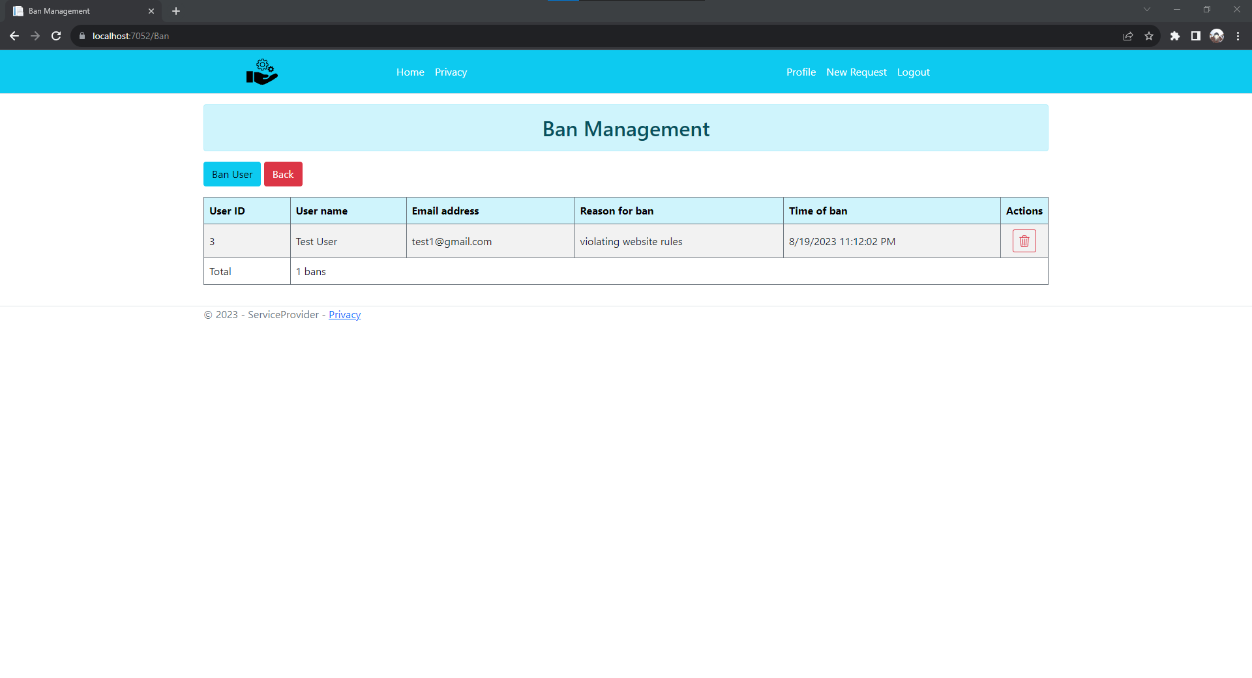

1. Ban User

Where an administrator can ban a certain user providing the reason for the ban.

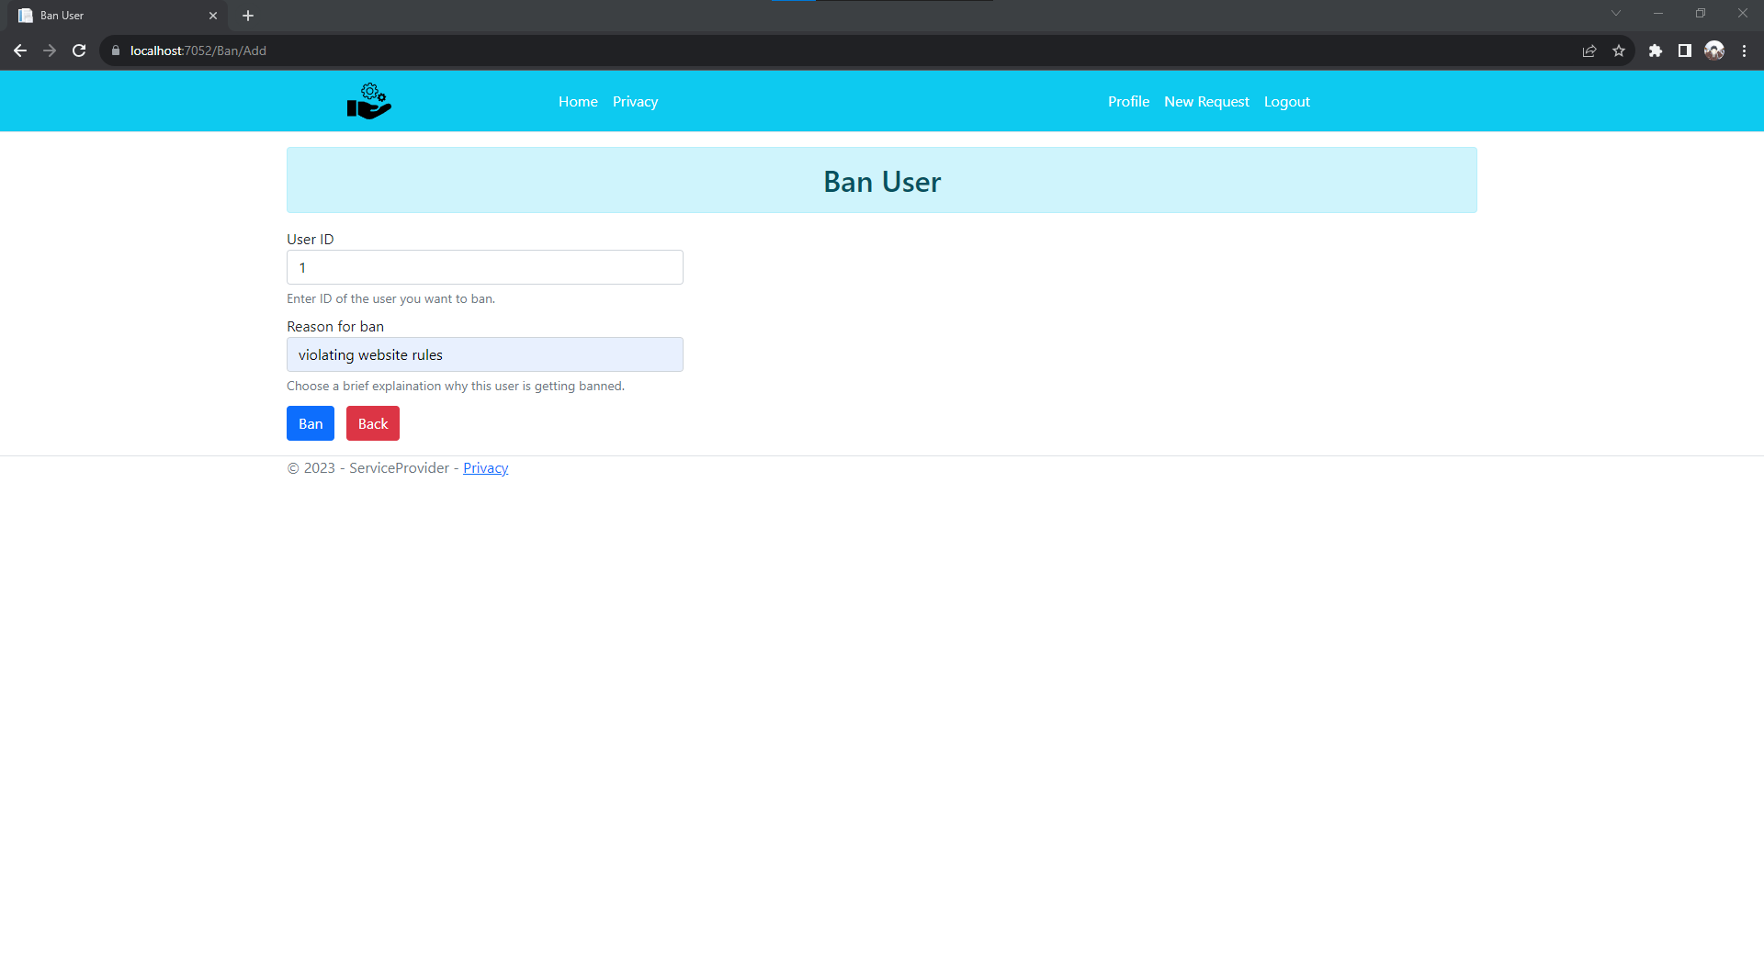

1. Unban User

Where an administrator can revoke the ban of a currently banned user.

